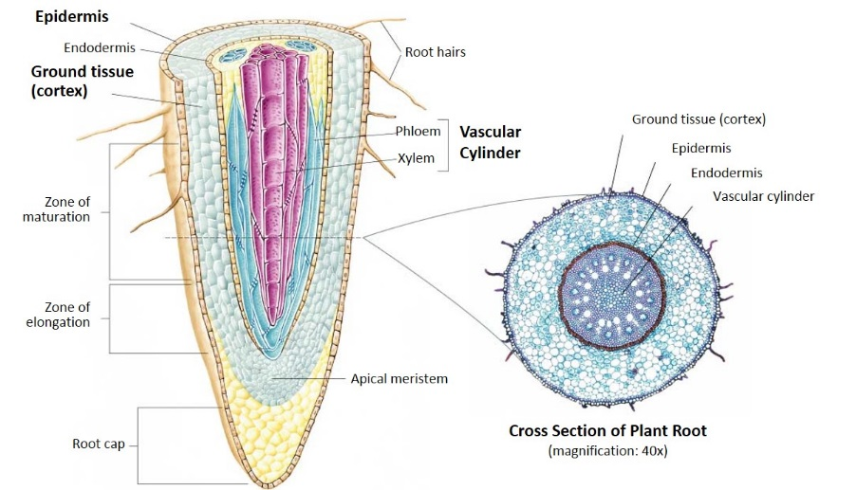
Roots

You will need:
- Carrots
- Growing plant with fibrous roots
- Plastic knife and cutting board
- Ruler
- Root Diagram
- Large bowl of water (1 per group)
- Root Investigation Sheet
- Magnifying lenses
- Newspaper

Directions
- Choose a carrot.
- Cut the carrot lengthwise.
- Compare the layers to those on the diagram.
- Draw what you see on the worksheet.
- Look at the plant with the fibrous roots
- If necessary, rinse the soil of the roots in the bowl of water as best as you can.
- Investigate the roots with a magnifying glass and identify the root hairs.
- Try to open up the small roots and investigate with the magnifying glass.
- Draw what you see on the worksheet.

The root is the organ of a plant that typically lies below the surface of the soil. Roots can also be aerial or aerating, that is, growing up above the ground or especially above water. Furthermore, a stem normally occurring below ground is not exceptional either. Therefore, the root is best defined as the non-leaf, non-nodes bearing parts of the plant's body. However, important internal structural differences between stems and roots exist. A root's four major functions are 1) absorption of water and inorganic nutrients, 2) anchoring of the plant body to the ground and supporting it, 3) storage of food and nutrients, 4) vegetative reproduction and competition with other plants. Roots often function in storage of food and nutrients. The roots of most vascular plant species enter into symbiosis with certain fungi to form mycorrhizae, and a large range of other organisms including bacteria also closely associate with roots. When dissected, the arrangement of the cells in a root is root hair, epidermis, epiblem, cortex, endodermis, pericycle and, lastly, the vascular tissue in the center of a root to transport the water absorbed by the root to other places of the plant

The two main types of roots are taproots and fibrous roots.
- Taproots: the primary root grows long and thick, while the secondary roots stay small. (ex. carrots or turnips)
- Fibrous roots: just secondary roots that grow and branch out. (ex. basil, lettuce, or spinach)

